**DBMS PROJECT ER DIAGRAM**

**GROUP MEMBERS**

**U19CS005 : JOSHI PRASHANT**

**U19CS013 : JAY H VAGHELA**

**U19CS022 : SANDEEP RATHOD**

**PROJECT DESCRIPTION :🡪**

* Creating a database to store information about employee, customer and booking information of trips for a JPS travellers company
* which helps to go customers on a trip in selected best and popular places with safety by providing them the suitable vehicle and a booked hotel in the visited place

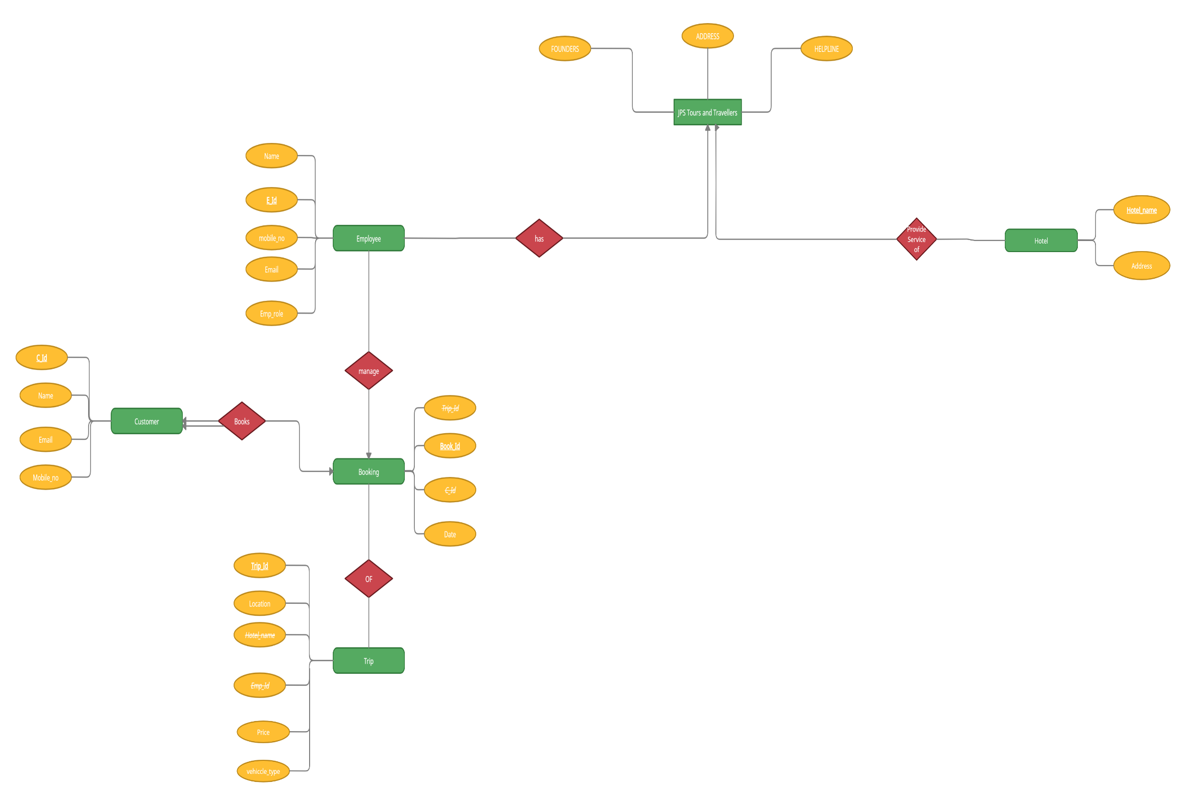

* **ENTITY SET, ATTRIBUTES AND PRIMARY KEY (RED) FOREIGN KEY(UNDER LINE)**

1. **JPS TOURS AND TRAVELLERS**

* **FOUNDERS**
* **HELPLINE NO.**
* **ADDRESS**

1. **EMPLOYEE**

* **E_ID**
* **E_NAME**
* **E_MOBILENO.**
* **E_ROLE**
* **E_EMAIL**
* **E_ADDRESS**

1. **CUSTOMER**

* **C_ID**
* **C_NAME**
* **C_MOBILENO.**
* **C_EMAIL**

1. **BOOKING**

* **BOOK ID**
* **TRIP ID**
* **C ID**
* **DATE**

1. **TRIP**

* **TRIP ID**
* **LOCATION**
* **HOTEL NAME**
* **EMP_ID**
* **PRICE**
* **VIHICLE**

1. **HOTEL**

* **HOTEL NAME**
* **ADDRESS**
* **RELATION SHIP SET**

1. **HAS :**  RELATES JPS TOUR AND TRAVELLERS WITH EMPLOYEE
2. **MANAGE :** RELATES EMPLOYEE WITH BOOKING ENTITY
3. **BOOKS :** RELATES CUSTOMERS WITH BOOKING ENTITY
4. **OF :** RELATES BOOKING WITH TRIP ENTITY
5. **SERVICE PROVEDS :** RELATES JPS TOUR AND TRAVELLERS WITH HOTEL

**CARDINALITY:**

|  |  |  |
| --- | --- | --- |
| **ENTITY** | **ENTITY** | **CARDINALITY** |
| **JPS** | **Employee** | **One to Many** |
| **JPS** | **Hotel** | **One to Many** |
| **Employee** | **Booking** | **Many to One** |
| **Customer**  **(total_participation)** | **Booking** | **One to One** |
| **Booking** | **Trip** | **Many to Many** |